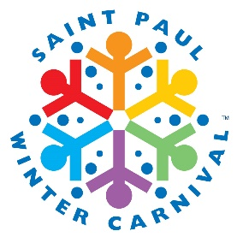
2024 Saint Paul Winter Carnival January 25th – February 4th

Greetings from the Saint Paul Winter Carnival!

The Saint Paul Festival and Heritage Foundation, a 501(c)(3) organization, is proudly underway in developing plans for the 2024 Saint Paul Winter Carnival, to be held January 25-February 4, 2024, and are anxiously waiting to reveal our 2024 Carnival buttons! As part of our annual Button Program, we invite you to join us in the upcoming celebration by participating as a local button seller.

The annual Button Program is our largest fundraiser and the longest Winter Carnival tradition. Sales from Winter Carnival buttons allow us to continue to plan free festivities for all of our community to enjoy and are an admired keepsake that often gets passed down through generations of Winter Carnival supporters. Your participation in the promotion and sale of the official Winter Carnival buttons helps ensure this event will remain the nation’s oldest winter festival for years to come!

Each year, we depend on local businesses like yours that partner with us to sell buttons on-location, helping us spread our fundraising efforts throughout the Twin Cities and metro areas. This year, we are also asking sellers to add buttons to their online ordering processes for increased traffic and to navigate current state regulations.

In addition to supporting our annual celebration, organizations selling buttons earn commission on button sales. As a button seller, you’ll earn $.50 for every $5.00 single button sold and $1.50 on each $19 4-button value pack. The more you sell, the more you earn! For more detailed program information, please refer to the enclosed Button Program FAQs.

To participate in this year’s program, please email your enclosed order form with the number of buttons you wish to sell to button@spfhf.org by November 22, 2023. You may also place your order online at www.wintercarnival.com under the “Button Central” tab. If you have further questions, please contact Jenny at (651) 223-7400 or jenny@spfhf.org.

We would greatly appreciate your support of the Saint Paul Winter Carnival and are looking forward to working with you this year!

Sincerely,
Lisa Jacobson, President & CEO
Saint Paul Festival and Heritage Foundation
651-223-7401 | lisaj@spfhf.org

